A free AWS course presendted by Yes-M Systems LLC

Prepared and presented by MS Viswanath

Lab-Manual – IAM – Identity Access management

Scenario-1

To create an user and group with console and API access for below services.

1. EC2 – Read access
2. S3 – full access
3. ELB – Read access
4. Autoscaling – Read Access

Steps.

1. Create an Custom Policy
2. Create a group
3. Create a user in the group
4. Check the output on the GUI and CLI

VISHWACLOUDLAB.COM

**Solution**

1. Create an custom policy

JSON Script of the policy.

{

"Version": "2012-10-17",

"Statement": [

{

"Sid": "VisualEditor0",

"Effect": "Allow",

"Action": [

"elasticloadbalancing:Describe*",

"ec2:Describe*",

"autoscaling:Describe*",

"s3:*",

"ec2:Get*"

],

"Resource": "*"

}

]

}

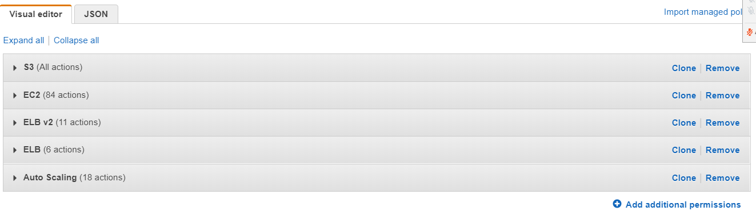

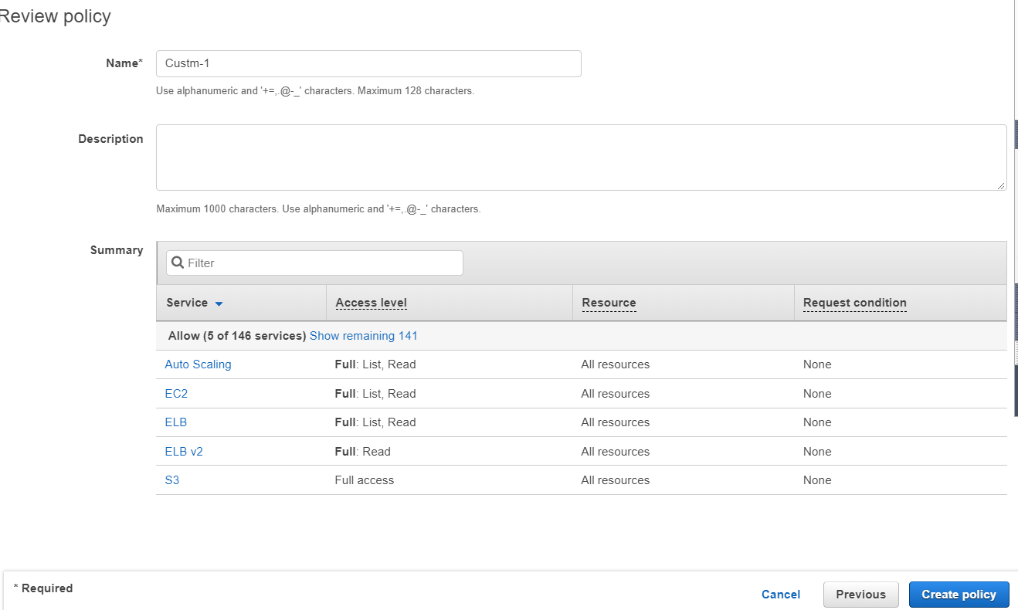

VISHWACLOUDLAB.COM

1. Create groups

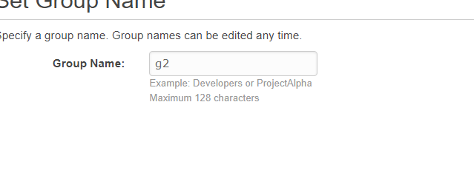

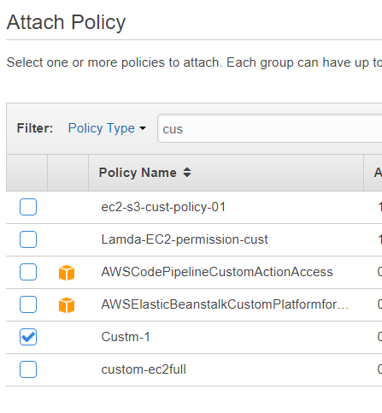

Attach the policy.

1. Create an user

Create an user with console and API access as below

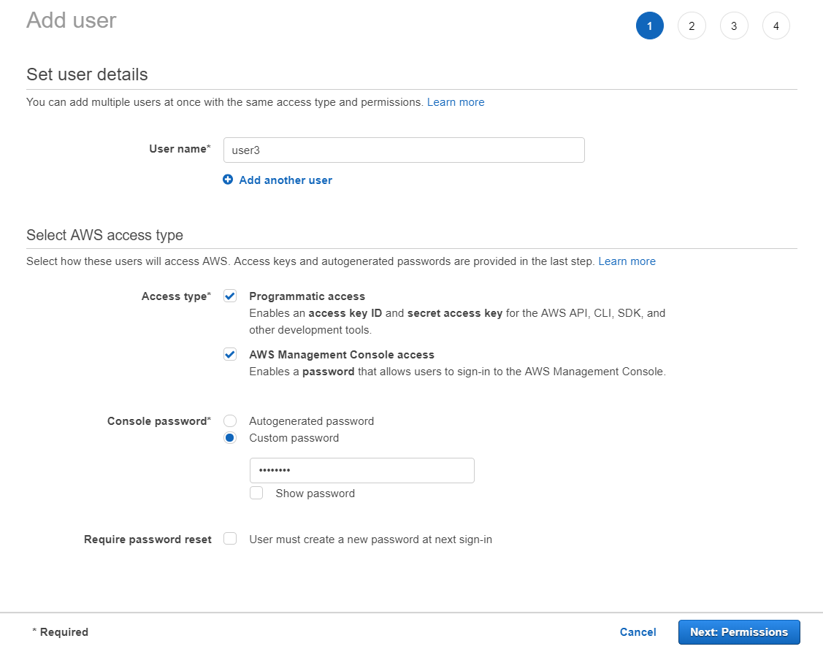

Attach it to the group that has been created.

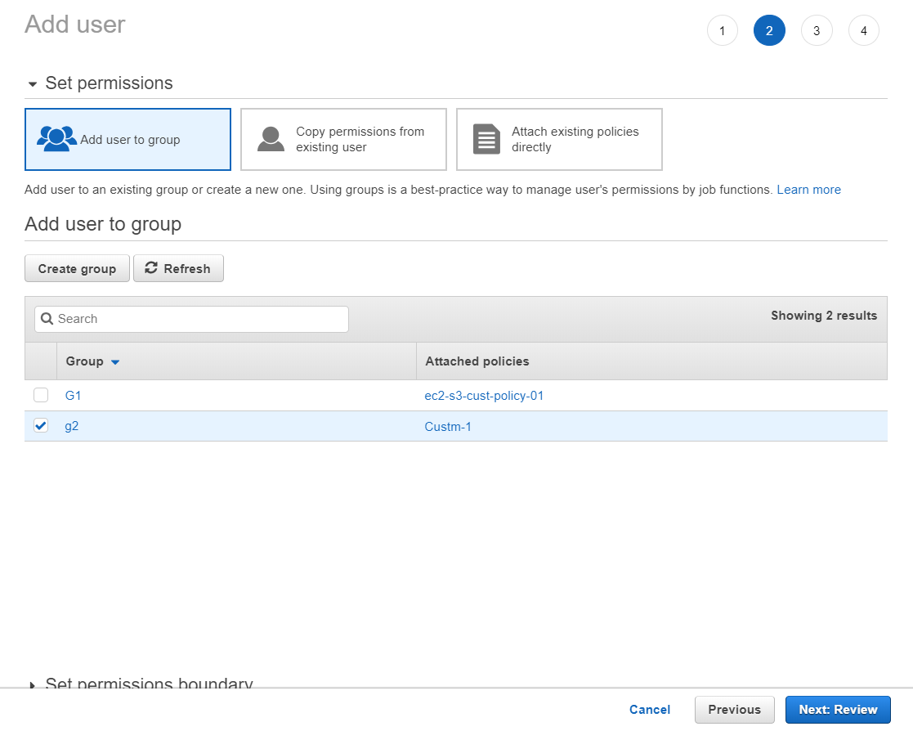

Make sure you copy the “secret key” for this user, as it would **not be shown AGAIN.**

1. Check the GUI output

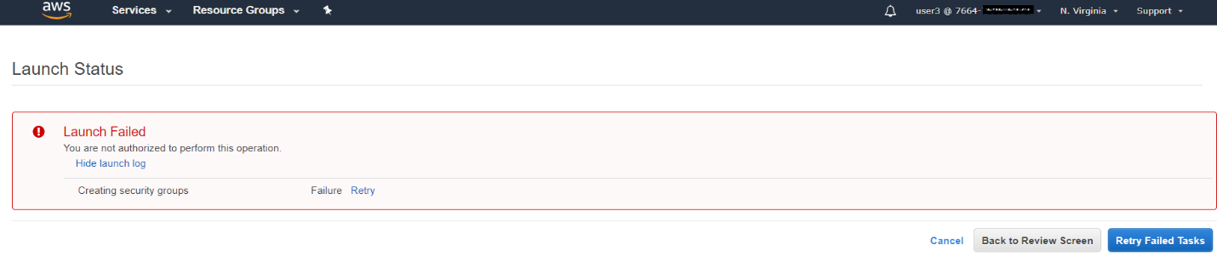

We are not able to create a VM, as expected.

We are not able to create a Volume, as expected.

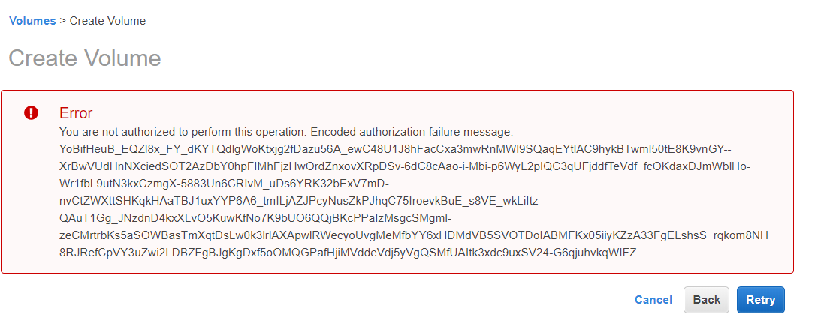

No access to the RDS,

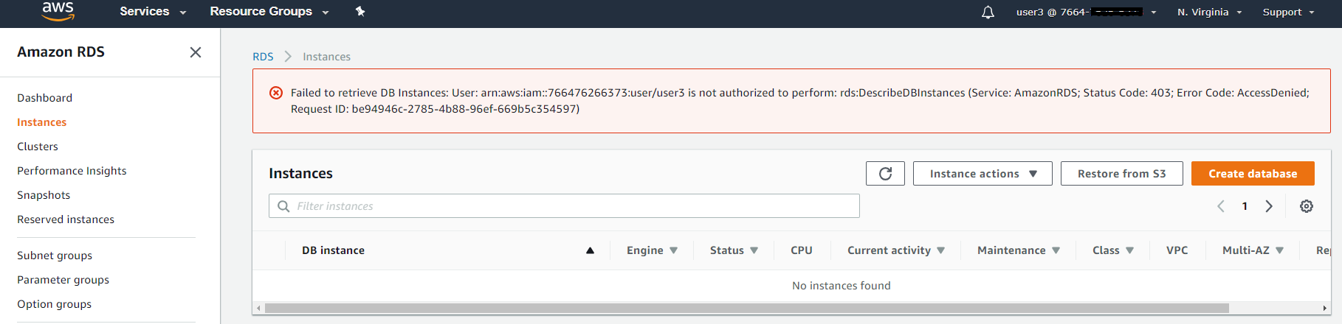

1. Check the CLI output

Able to get the list for EC2 and S3

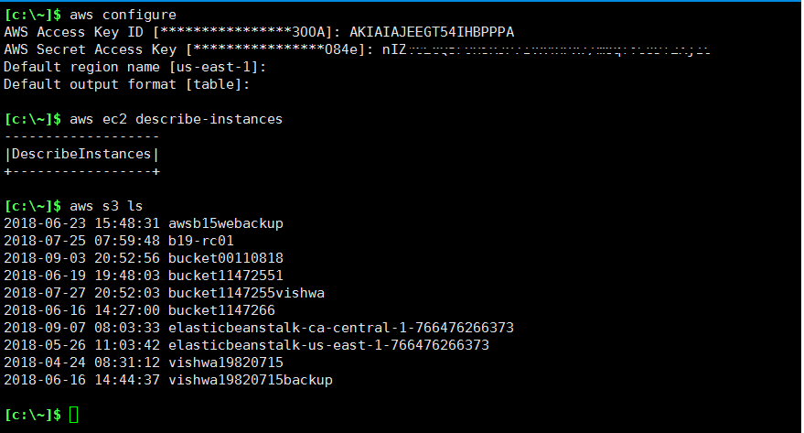

Not able to list the users in the IAM, as this user does not have access to it.

